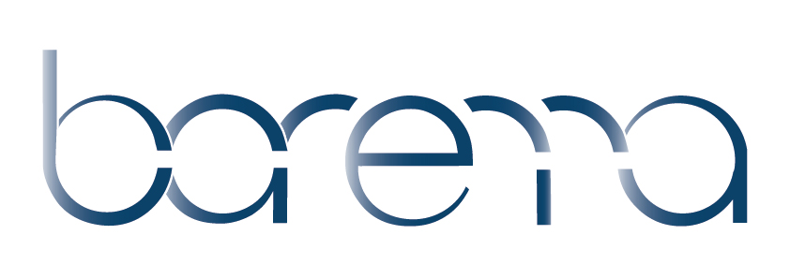**Autumn Meeting Agenda**

Association of Anaesthetic &  
Respiratory Device Suppliers

**Tuesday 11th October 2022 9.30am**

Grovefield House Hotel, Taplow Common Road, Burnham, Buckinghamshire, SL1 8LR

**09:15** **REGISTRATION – TEA AND COFFEE**

**WELCOME** - Nicki Dill, Barema Chair

**09:45 AGM – Members only**

**SESSION ONE - Innovation**

10:15 Naomi Bennett, Senior Innovation Partnership Officer, Asthma and Lung UK

* **Patient Insight and Innovation**

10:45Dr Peter Young, Vice President of Association of Anaesthetists, Safety Committee Chair

**Update on Safety**

**11:15 TEA AND COFFEE**

**SESSION TWO – Research**

11:30 James Bowness, Consultant Anaesthetist, Aneurin Bevan University Health Board Senior Medical Advisor, Intelligent Ultrasound DPhil Candidate, University of Oxford

* **Artificial Intelligence for Ultrasound Scanning in Regional Anaesthesia**

Brendan McGrath, Consultant in Anaesthesia & Intensive Care Medicine, ICU consultant and an honorary professor, [Manchester University NHS Foundation Trust](https://mft.nhs.uk/)

* **Safe and Effective Above Cuff Tracheostomy Vocalisation (SEA CTV): A device development study**

12:30 Dr Gareth Kitchen, Senior Clinical Lecturer. Honorary Consultant Anaesthetist, University of Manchester

* **HTA funding, via NICE appraisal a route to bring innovations to the NHS**

**13.00 LUNCH**

**SESSION THREE** - **Sustainability**

13:30 Dr Elleanor Damm, Dual Trainee Intensive Care Medicine/ Anaesthesia - West Midlands

* **First Do No Harm - How can I practice sustainable medicine?**

14:00Nicole Fletcher**,** Sustainable Procurement Lead, NHS

* **The NHS path to Net Zero Products**

14:30 Thomas Haytack, Product Manager, Anaesthesia & I.V Pharma - B Braun

* **Barema Environment & Sustainability Special Interest Group**

**14:45 TEA AND COFFEE**

**SESSION FOUR - Updates**

15:00Frankie Wallace,Scan for Safety Supplier Engagement Lead, Scottish Government

**NHS Scotland Scan for Safety**

15:30 Terry Longman, Barema consultant

* **Standards Update**

15:50 Nicki Dill, Barema Chair

* **Members’ Forum (**Members only)

16:30 Closing Remarks

Association of Anaesthetic &  
Respiratory Device Suppliers



**Association meeting rules**

It is the strict policy of Barema to comply with the letter and spirit of European Union (EU) antitrust law and similar laws in the EU Member States and other countries.

**The prudent rule to be followed at all Barema meetings and gatherings is that no commercial topics should be discussed.**

Barema:

* has a mission to achieve the highest level of safety and environmental care for anaesthetic, respiratory and related products.
* shall not be used as a forum for the discussion of business secrets.
* meetings are conducted to avoid even the appearance that its members are taking common action which might restrict competition.
* meeting discussions are limited to (written) agenda topics and minutes shall be provided.
* prohibits any discussions or exchange of information that might constitute or imply an agreement or concerted practice concerning:

(1) prices or price factors, including discounts, rebates, and reductions.

(2) costs and demand structure.

(3) profits and profits margins.

(4) output and sales.

(5) market shares and sales territories.

(6) investments and marketing plans.

(7) bidding or refraining from bidding.

(8) credit conditions or any other terms or conditions of sale; or

(9) selection, rejection, or termination of customers or suppliers.

These meeting rules apply to all meetings under the guidance of Barema.

December 2022