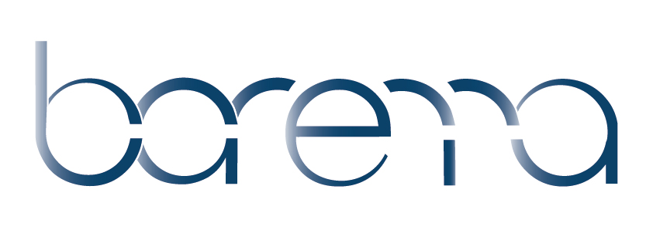**Spring Meeting Agenda**

Association of Anaesthetic &  
Respiratory Device Suppliers

**28th March 2023 9.30am**

Vygon, V Park

Gateway North,

Latham Road, Swindon

Wiltshire

SN25 4DL

**09:30** **REGISTRATION – TEA AND COFFEE**

**09:55** **WELCOME** - Nicki Dill, Barema Chair

**10:00 SESSION ONE – Sustainability**

David Lawson, Director of Medical Technology, Department of Health and Social Care

* **New Strategy for Medical Technology: Now or Never**

10:30 Dave Walker, Account Manager - Instrumentation Group, Parker. Barema ESSIG member

* **Barema Environment & Sustainability Special Interest Group (ESSIG) - Parker Sustainability Report**

Paul Sim, KS – Medical Devices Knowledge Manager, BSI Group. Barema Council Member, ESSIG Chair

* **Standards Update**

11:00Peter Young, Association of Anaesthetists

* **Update on Safety**

11:30 Dr Nandita Divekar, Consultant in Anaesthesia and critical care, Medway Maritime Hospital

Dr Namrata Maheshwari, Specialty doctor critical care, Medway Maritime Hospital

Dr Angela Liao, Anaesthetics trainee, Medway Maritime Hospital

* **Small wise steps by our team could reduce huge wastage in the NHS**

**12:15** **LUNCH**

**13.15** **SESSION TWO - Updates**

Terry Longman, Standards Consultant

* **Standards Update**

**SESSION THREE - Patient Safety**

13:35 Sarah Jennings, Patient Safety Clinical Lead - Medical Devices

Barry Walker, Supply chain, NHS England

* **NHS England Joint Neuraxial and Regional Anaesthesia Connectors (NRFit) Statement**

14:05 Janet Monkman, Chief Executive, Academy for Healthcare Science

* **The National Life Science Register, Protecting patients, progress and next steps**

**14:35 TEA AND COFFEE**

15:00 Dr Fiona Kelly, Consultant in Anaesthesia and Intensive Care Medicine, Royal United Hospitals Bath NHS Foundation Trust. Chair of Difficult Airway Society/Association of Anaesthetists human factors guideline group

* **Improving the Safety Culture in Anaesthesia**

15:30 Nicki Dill, Barema Chair

* **Members’ Forum (**Members only)

16:00 Closing Remarks

Association of Anaesthetic &  
Respiratory Device Suppliers



**Association meeting rules**

It is the strict policy of Barema to comply with the letter and spirit of European Union (EU) antitrust law and similar laws in the EU Member States and other countries.

**The prudent rule to be followed at all Barema meetings and gatherings is that no commercial topics should be discussed.**

Barema:

* has a mission to achieve the highest level of safety and environmental care for anaesthetic, respiratory and related products.
* shall not be used as a forum for the discussion of business secrets.
* meetings are conducted to avoid even the appearance that its members are taking common action which might restrict competition.
* meeting discussions are limited to (written) agenda topics and minutes shall be provided.
* prohibits any discussions or exchange of information that might constitute or imply an agreement or concerted practice concerning:

(1) prices or price factors, including discounts, rebates, and reductions.

(2) costs and demand structure.

(3) profits and profits margins.

(4) output and sales.

(5) market shares and sales territories.

(6) investments and marketing plans.

(7) bidding or refraining from bidding.

(8) credit conditions or any other terms or conditions of sale; or

(9) selection, rejection, or termination of customers or suppliers.

These meeting rules apply to all meetings under the guidance of Barema.

March 2023